Orchids Experience
Cusco, Machu Picchu, Sacred Valley

Guide: Washington Gibaja Tapia.

DAY 1 (09/05/2015) ARRIVE LIMA Upon arrival in Lima, you will be met at the airport by a Magical Tours Peru representative and transferred to the Hotel at Airport www.costadelsolperu.com/peru/hotels/lima

DAY 2 (09/06/2015) LIMA – CUSCO Morning departure for flight to Cusco, center of the Inca Empire. Magical Tours Peru guides pick you up at the airport for a quick tour of the beautiful Plaza De Armas. From there, you will be taken to the Hotel, where you will be free for the remainder of the day to relax and acclimatize to the altitude (10,856 ft.) (B, L) www.andeanwingshotel.com

DAY 3 (09/07/2015) CUSCO CITY TOUR The morning begins with a guided walking tour of the local markets of Cusco, the colonial cathedral, and Koricancha, the impressive Temple of the Sun. After a break for lunch, you'll depart for an afternoon tour of Cusco's temples and visit each distinctive Inca sight, including the fortress of Sacsayhuamán with its megalithic stone terraces; Kenko, with its carved stone surfaces and subterranean altars; the small fortress of Puka Pukara that protected the royal capital from attacks, and the water temple Tambo Machay. An evening briefing session orients you to the upcoming day. Overnight at: www.andeanwingshotel.com . (B, L)

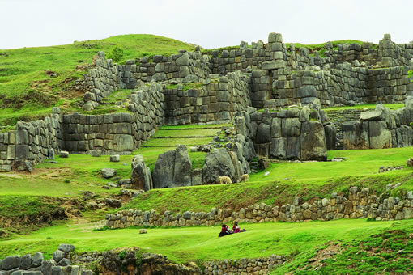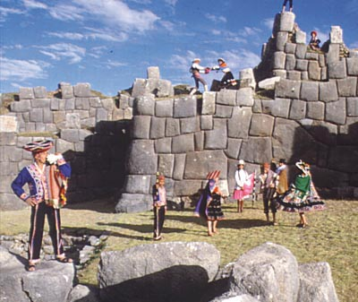
DAY 4 (09/08/2015) CUSCO- SACRED VALLEY Embark upon a day-long guided excursion through snowcapped mountains to the legendary Sacred Valley, as majestic today as it was during the reign of the Incas. Along the way, Inca terracing climbs the steep valley walls and the beautiful temples of Pisac inspire panoramic views of the jagged granite mountains. Pisac is the location for one of the best textile markets in the Andes. There, your bargaining skills and enjoy the local culture. After lunch, reach Ollantaytambo (9,185 ft.), a small town with an impressive Inca fortress, with princess baths and more. Tour the ruins and enjoy this small traditional town. Overnight at Hotel Pakaritampu in Ollantaytambo. www.pakaritampu.com (B, L)

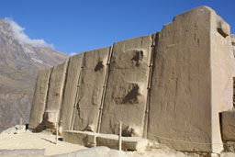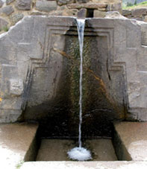
DAY 5 (09/10 /15) Inca Trail to Machu Picchu. After breakfast, transfer to the train station and ride the train for 1 hour to the starting point of KM 104, considered as the beginning the Sacred Trail to Machu Picchu. This trail starts at Chachabamba Archeological Site. This is the “short version” of the Inca Trail. The 3 first hours are strenuous (3 miles, altitude gain from 7,217 to 9,186 ft), seeing the waterfalls and passing by the magnificent site of Winay Huayna makes it worth the effort. Box lunch provided to eat along the way. After good scenery for photos, we will walk for 2 hours (4.5 miles and mostly level) more to reach the gate of the sun and view Machu Picchu http://whc.unesco.org/en/list/274 from this unique perspective only 40 minutes from Machu Picchu. After good photo opportunity, take the bus to Machu Picchu Town. Dinner on your own. (B,L,D) www.hotelescasadelsol.com
DAY 6 (09/11/15) Machu Picchu – Ollantaytambo. Bus to Machu Picchu leaving by foot in time to avoid the crowds and see the sun illuminating the walls of this sacred and magical place. (Distance 1.5 miles) Explore the ruins for about 4 hours. We can do some meditation with music at this magical place if you wish. Buffet lunch with a view of the Sacred Mountains. Late afternoon train back to Ollantaytambo where you will return to hotel for retrieving bags, dinner and sleep. (B,L) Accommodation at: www.pakaritampu.com
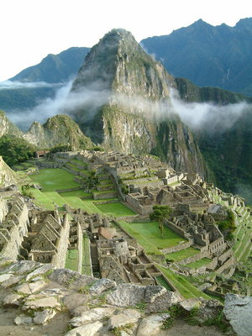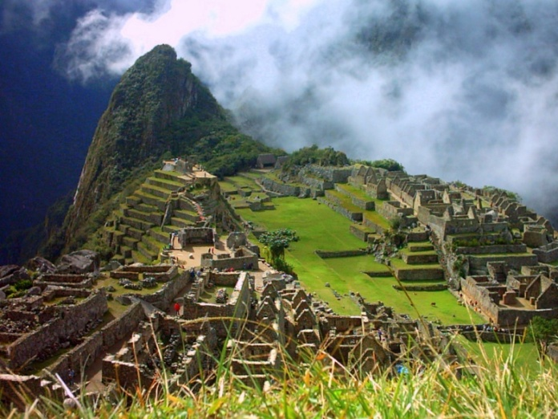
DAY 7 (09/12/15) CUSCO - LIMA – US
Morning Go to a native community to share service with them: Hot Chocolate/ Solar Lights or other activities. Back any time to the hotel to be transfer to the Airport for your Afternoon flight to Lima and then connect home. (B, L)
Breakfast/Lunch/Dinner

HOTELES: Are listed in each day, you can get more information by entering to their Web page.

Includes:
- Flights from Lima – Cusco
- Private ground transportation
- Hotels.
- All breakfasts and lunches nutritious meals and snacks while on the trek (Vegetarian option available).
- 1 diner in MP.
- Shaman-trained Guide and expenses.
- Entrance fees to Machu Picchu, Inca Trail, Sacred Valley and Cusco.
- Train fares.
- Bus to Machu Picchu round trip
- Bottle of water daily.
- Bread and Hot Chocolate to share with the children in the native communities.
Does Not Include:
- International airfares.
- Most Dinners.
- Extra beverages.
- Gratuities (bellmen, waiters, guide, drivers)

What to BRING:
- Hiking boots, comfortable walking shoes and good sandals
- Waterproof Jacket and pants
- Good Camera and extra battery and memory card
- Good flash light
- 220/ 110V (plug) adaptor
- Insect repellent
- Sun block, sunglasses, hat
- Bottle for water
- Some school supplies to share with the children while visiting communities

LIMA TRANSPORT:
Sr. Luis Espichan
Tel: (51 84) 994 112 401 / 979469 346

Price per Person - US $2400.00
Includes $500.00 tax deductible contribution to The Orchids of Light Foundation

